Your chance to WIN! 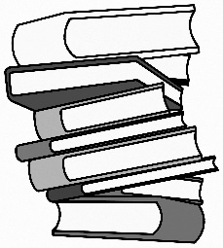
Enter to stand a chance of winning a £10 book voucher.

- “One ring to rule them all”. Series of books this line relates to.

- Book by Ian McEwan that starts with a hot air balloon.

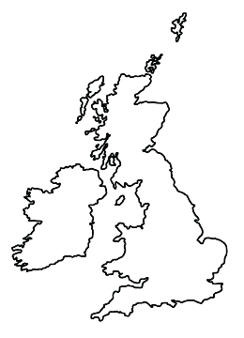
- Author of books about Jack Ryan.

- He wrote notes whilst travelling around a small island.

- EM Forster’s book set in Florence.

- The members of the Famous Five.

- The name of AA Milne’s gloomy donkey.

- Author of Birdsong.

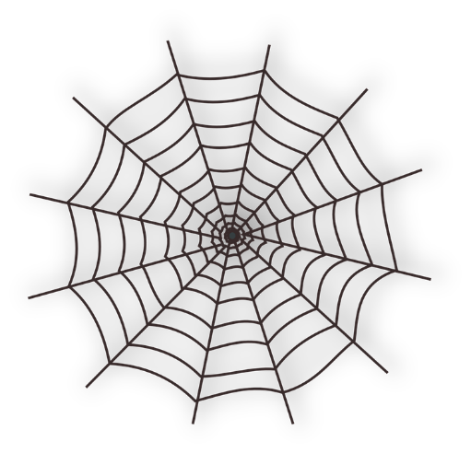
- The name of the pig in Charlotte’s Web.

- Agatha Christie’s Belgian detective.

- Former junior doctor, now comedian and author, who wrote “This is Going to Hurt”.

- “The Boy who Lived”.

Name……………………………………………………………………………………

Email address………………………………………………………………………..

Phone number……………………………………………………………………...

Please return all entries to Telford or Shrewsbury Health Libraries by Friday 18th August.



